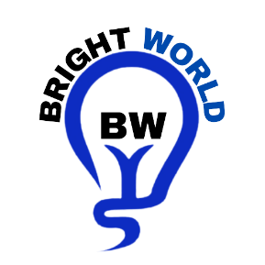

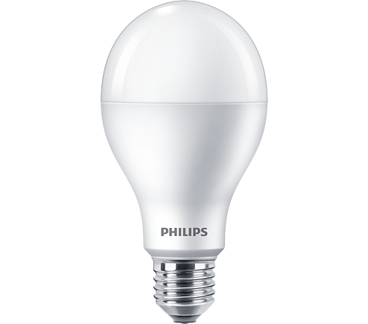

LED BULB

* 14.5W-120(120W for Incandescent;27W
* E27
* Cool Daylight

**Rs 300.00**